Network Traffic Grounding Evidence and Visualization

Abstract

Descriptions of network traffic - attack narratives, protocol behavior claims, or general traffic summaries - are often produced without systematic verification against the underlying evidence. As such descriptions increasingly originate from or are consumed by AI systems, the gap between narrative and evidence grows both more common and harder to catch manually: critical stages may be omitted, described activity may not have occurred at all, and unrelated traffic may be mistakenly attributed to the narrative.

PANGEA is a tool for grounding descriptions of network traffic in packet-level evidence (PCAP). Given a textual description - of an attack, a protocol's expected behavior, or ordinary traffic - PANGEA decomposes it into discrete steps or claims and links each to the specific packets or flows that support it.

This makes PANGEA applicable both to high-stakes verification - auditing attack reports or validating protocol conformance against captured traffic - and to everyday description-to-evidence linking, such as connecting a plain-language traffic summary to the packets that produced it.

Results are surfaced through a visual interface that presents, per step or claim, its grounding status, the underlying evidence, and any flagged discrepancies - enabling users to audit both human-written and AI-generated descriptions of network behavior against ground-truth traffic.

Visualization is necessary to keep human in the loop

In addition to Grounded data we get grounded visualization that can be later used for education purposes or research

Background

Methodology

The system is built as a pipeline to ensure separation of forces

The pipeline includes the following steps:
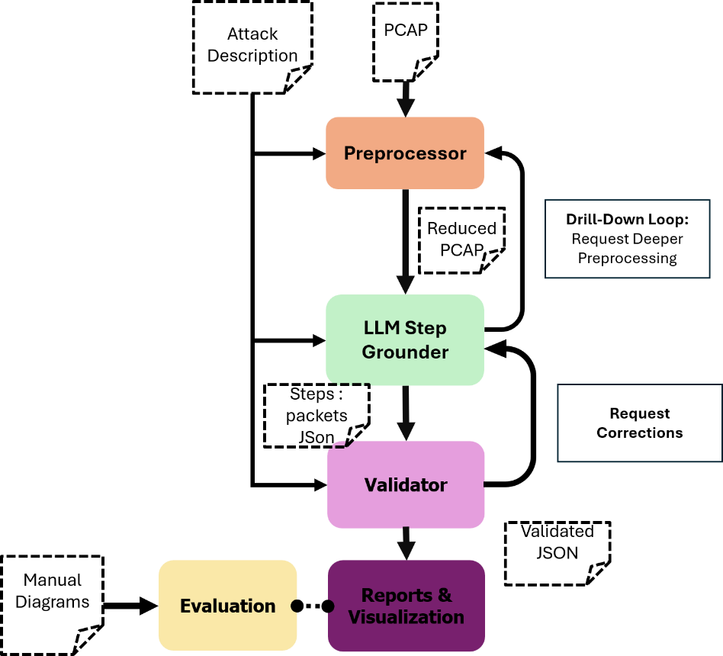

Preprocessing

Purpose

Reduce PCAP volume to fit within a defined token/packet budget, reliably. The goal is to fit packets within tokens constraints and avoid feeding the pipeline with redundant packets.

Packets will be either compressed, aggregated or removed.

Requirements
  - R1- Referential Integrity
Every item in the output (raw sample or aggregate stat block) must carry an unambiguous reference back to the original PCAP - packet id and timestamp at minimum - so that later stages (Validator, drill-down) can retrieve the exact original packet(s) without re-scanning or re-parsing the full capture.
  - R2 - Temporal Order Preservation
The chronological order of retained items must reflect the original capture's timeline. Compression must not reorder or merge packets across time in a way that obscures sequence.
  - R3 - Aggregate Traceability
Every packet removed from the raw representation (whether folded into a compressed pattern or dropped for parse failure) must leave a quantitative trace: at minimum, count, byte volume, and unique source/destination cardinality, attached to a retained representative. No packet may vanish without a trace of its existence surviving in the output.
  - R4 - Budget Compliance (hard, not best-effort)
The stage must reliably produce output within the specified budget (packet count and/or token estimate) - not "usually" or "approximately." If naive compression would exceed budget, the stage must adapt (e.g., tighten sampling_limit dynamically) rather than silently truncate the tail of the capture, which would violate R1/R4 for whatever was cut.
  - R5 - Protocol/Attack-Type Agnosticism
The stage's compression logic must not depend on knowledge of what kind of attack, protocol, or traffic pattern it is processing — it must apply the same structural fingerprinting logic uniformly.

Structure
The preprocessor is composed of two modules:
Filter Generator
Responsibility: translate a free-text Network Traffic Description into a filter expression that narrows the PCAP to relevant traffic, before the expensive structural work happens in the Reducer.

Core logic:

- Receive Attack Description (raw text).
- Infer the relevant protocol/traffic scope implied by the description - e.g. protocols mentioned or implied (TCP/UDP/ICMP/ARP/DNS/HTTP...), ports if named or inferable from named services, IP/subnet hints if explicitly given.
- Translate that inferred scope into a filter expression in the target syntax.
This step will be done using a combination of a small LLM model and algorithms
Inputs:
Input | Type | Required? | Role
Attack Description | Text File | Yes | Attack description text

Outputs:

Output | Description
Filter String | The Filter String created from the description

Reducer
Responsibility: apply the filter, then deterministically compress the (filtered) PCAP to fit within budget while satisfying the requirements.

Core logic:
- Apply filter_string (BPF-level, before per-packet dissection, for efficiency).
- For each remaining packet: parse L2/L3/L4 identity; on parse failure, increment a drop-counter and continue (never silently vanish - satisfies R3 even for unparseable packets).
- Compute a structural fingerprint per protocol (TCP flag/stream-state, UDP port, ARP opcode+MAC, ICMP type/code) - protocol-agnostic to attack type (R5).
- Bucket by fingerprint; retain first Filtering_limit raw instances per bucket; fold the rest into aggregate stats attached to the first retained instance (count, bytes, unique src/dst) — this is R3's mechanism.
- Preserve original chronological order in the output list regardless of bucketing (R2) - i.e., aggregation must not reorder retained items relative to the original capture timeline.
- Track running token estimate as items are retained.
- If projected output will exceed Token_Budget before the full capture is processed: stop, do not truncate silently — return everything successfully processed so far, set Budget_status = exceeded, and report where processing stopped (packet id/timestamp) so downstream knows exactly what wasn't covered.
- Emit Reduced_representation, Compression_stats, Budget_status, Dropped_parse_failures_count. Fingerprint_index

Inputs:
Input | Type | Required? | Role
PCAP | Binary File | Yes | Raw packets traffic file
Token_budget | Int | Yes | Final token budget from processed PCAP.  Can be calculated by the $main$module:  $$TokenBudget=$$  $$context window size-system prompt-attack descriptin-expected output -safety margin$$
Filtering_limit | Int | Yes | How many raw packets should be saved for each fingerprint before aggregation
Filter_string | String | Yes | The filtering string output of Filter Generator
Max_packets | Int | No | Bounding the number of packets

Outputs:
Output | Description
Reduced Representation | Structured list of retained packets/flows, each traceable to original PCAP (packet id, timestamp)
Compression Stats | raw packet count in, packet count out, ratio achieved, whether budget was met
Aggregate metadata per collapsed pattern | count, byte volume, unique src/dst cardinality — attached to the representative sample of each pattern
Fingerprint_index | lookup structure built using the reduced representation, with protocols as keys and packets as values

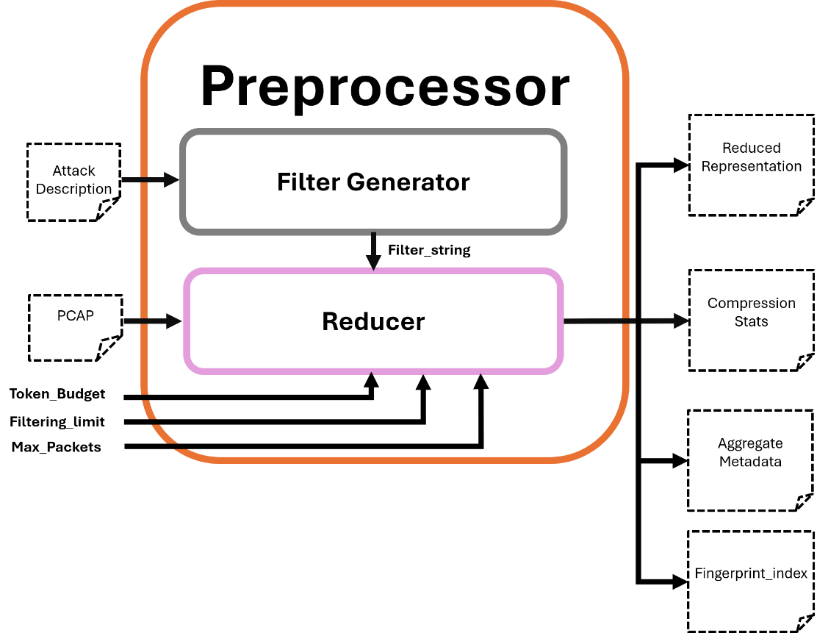

LLM Grounder

Purpose
- The Grounder is the stage of the pipeline where the traffic description and the packet-level evidence (Reduced PCAP) are brought together for the first time.
- Its job is to decompose a free-text description into atomic, checkable claims, and to determine - for each claim - whether it is supported by the traffic evidence, unsupported, or uncertain enough to require deeper investigation.
Inputs:
  - Network Traffic Description — the free-text input (attack narrative, protocol description, or ordinary traffic description)
  - Reduced PCAP — the compressed packets representation from the Preprocessor
  - Fingerprint_index — the lookup structure built during Preprocessing's compression pass, reused here rather than rebuilt
Outputs:
  - Matching JSON - a single, unified structured output containing all claims, their grounding results, and resolved actors
  - The JSON File is in the following format:
    - Actors -> ip mapping
    - Claims -> grounding mapping

1. {
2.
3. "actors": [
4. {
5. "actor_id": "attacker",
6. "role": "attacker",
7. "description_ref": "the external host performing the scan",
8. "resolved_endpoints": ["203.0.113.17"],
9. "resolution_confidence": 0.9,
10. "resolution_basis": "consistent source IP across all recon-phase packets matching expected_indicators"
11. },
12. {
13. "actor_id": "victim",
14. "role": "victim",
15. "description_ref": "the internal web server",
16. "resolved_endpoints": ["10.0.0.5"],
17. "resolution_confidence": 0.95,
18. "resolution_basis": "destination IP of scan traffic; matches described role as public-facing server"
19. }
20. ],
21.
22.
23. "claims": [
24. {
25. "claim_id": "c1",
26. "text": "...",
27. "expected_indicators": {...},
28. "actor_refs": ["attacker"],
29. "grounding": {
30. "status": "grounded | unsupported | uncertain_needs_drilldown",
31. "confidence": 0.0-1.0,
32. "linked_packets": [...],
33. "linked_aggregate_refs": [...]
34. }
35. }
36. ]
37. }
38.

Internal Structure

The Grounder is composed of two sub-components:

Claim Extractor
Responsibility: convert free text into a structured list of atomic claims.
Input: Traffic Description only. This component never receives the Reduced PCAP — it works purely from the narrative text, so its output cannot be biased by what evidence happens to exist in the capture.
What it does:
- Splits the description into a flat list of atomic claims.
- For each claim, defines any technical term used within the claim's own text (a prompting instruction, not a separate processing step).
- Identifies actors referenced in the description (roles such as attacker/victim/client/server) - role identification only, not IP resolution.
- Derives expected_indicators for each claim, in two layers:
  - Structured hints (protocol, port, flags, direction, volume pattern, cardinality pattern) - used for algorithmic matching.
  - Free-text fallback (indicator_description) — used when a claim doesn't reduce cleanly to structured fields.
Mechanism: necessarily LLM-based — this is a natural-language understanding task with no viable algorithmic substitute.

Evidence Matcher
Responsibility: determine, for each claim, whether the Reduced PCAP supports it — and resolve actor roles to actual IP endpoints.
Input: claims + actors (from Claim Extractor), Reduced PCAP, Fingerprint_index.
Functionality:
- Actor Resolution (sub-responsibility, not a separate top-level component)
  - For each actor role, search the Fingerprint_index for traffic patterns matching that role's expected structural signature (e.g., "attacker" → source with high destination-cardinality, consistent with scanning behavior).
  - A single unambiguous match → resolved automatically, with a confidence score and a stated basis.
  - No match → actor marked unresolved; any claim referencing it is later flagged uncertain_needs_drilldown without a wasted lookup.
  - Multiple competing matches → escalate to the LLM, providing only the specific candidates (not the full Reduced PCAP).
- Claim Grounding (per claim)
  - If the claim depends on an unresolved actor, it is immediately flagged uncertain_needs_drilldown.
  - Otherwise, build a fingerprint key from the claim's structured expected_indicators and perform a lookup against Fingerprint_index.
  - A single clean match → grounded, with linked packet IDs and/or aggregate references attached.
  - No match at all → unsupported (false-positive candidate).
  - A match exists only as aggregate/compressed statistics (no raw packet detail) → uncertain_needs_drilldown.
  - Multiple competing matches, or no usable structured hints (fallback to indicator_description only) → escalate to the LLM, which receives only the relevant slice of the Reduced PCAP, not the whole capture.
Mechanism: algorithmic-first (index lookup), with LLM escalation reserved for ambiguous or non-structured cases. This keeps the cost of grounding close to O(P + N) rather than O(N·P), and avoids re-feeding the full Reduced PCAP to the LLM once per claim.

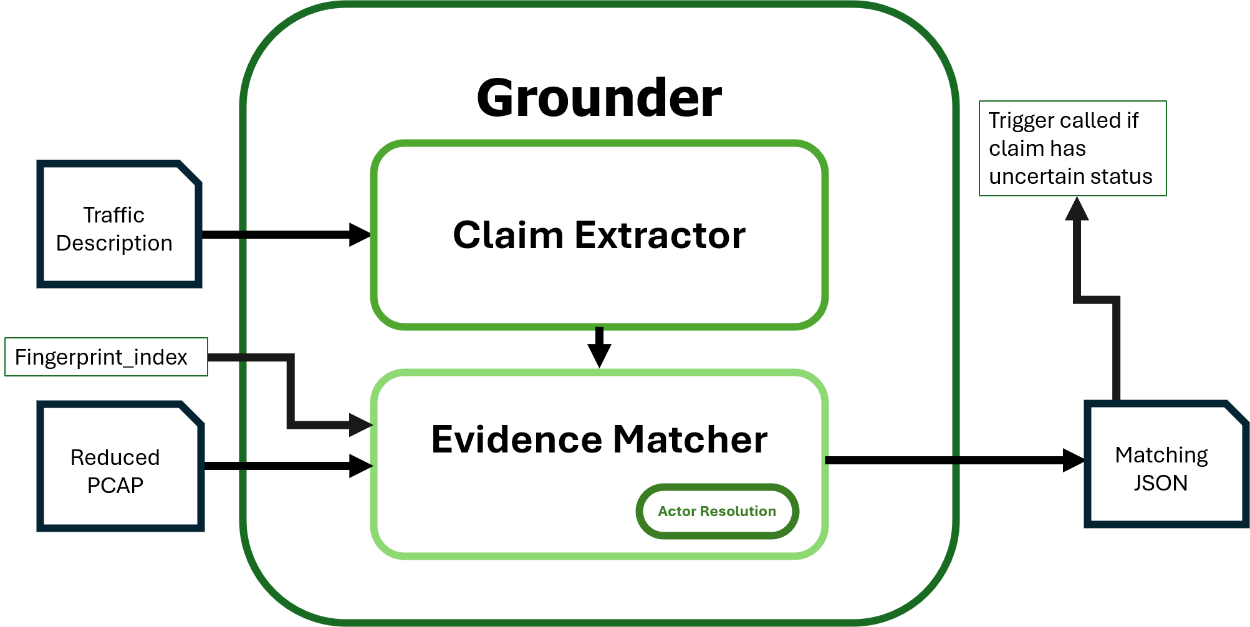

Validator

Purpose:
- The Validator performs independent quality assurance on the Grounder's output. It does not re-derive claims or grounding from scratch - its sole job is to assess whether the Grounder did its job faithfully, and to flag suspected errors with a confidence score.

Inputs:
- Attack Description - the original free-text input
- Claims: groundings - the Grounder's full output (claims, each with its grounding result)
- Reduced PCAP - the same compressed packet representation the Grounder worked from
Outputs:
- Validator assessment - a single structured object containing all flagged suspicions, each with a confidence score and justification
1.
2. "validator_assessment": {
3. "extraction_check": {
4. "extractor_fp": [ { "claim_id": "c3", "suspicion": 0.8, "reason": "..." } ],
5. "extractor_fn": [ { "suspected_missing_claim": "...", "text_span": "...", "suspicion": 0.6 } ]
6. },
7. "linkage_check": {
8. "matcher_fp": [ { "claim_id": "c1", "suspicion": 0.7, "reason": "structural match but semantically unrelated" } ],
9. "matcher_fn": [ { "claim_id": "c2", "missed_evidence_ref": "...", "suspicion": 0.5 } ]
10. }
11. }
12.
2.

Field | Meaning

Two Failure Surfaces

We want to make sure that:

All claims are correct:

Avoiding FPs: No made-up claim by The Grounder

Avoiding FNs: The Grounder did not miss a claim

All packets linked to the claims are correct:

Avoiding FPs: The Grounder did not attach incorrect packets to any claim

Avoiding FNs: packets that should be attached to a claim are not missed

- Keep for now: Basic algorithms that need validation:
  - Check FPs:
For-each step in step-packets dict.keys:
    - For each packet in step.values:
      - Does this packet exist?
      - Does the step metadata match the packet metadata (src, dst, protocol..)
      - Additional logical rules
      - If all passed: continue:
      - Otherwise: throw packet – indicate!
  - Check FNs:
Residual packets = filtered packets that were not used
interesting_keywords = database of keywords that make packets not ignorable
For-each packet in all Residual packets:
If packet contains a keyword from interesting_keywords:
Check again!
- Working with labeled PCAPs
  - Marking important packets
  - Giving a score based on FPs and FNs

Internal Structure

Extraction Checker

Responsibility: verify that claims[] is a faithful and complete representation of the Traffic Description text.
Input: Traffic Description + claims[].text only. Deliberately excludes the Reduced PCAP - this is a text-to-text comparison, not an evidence check.
What it checks:
- Ex_FP (Extractor false positive): a claim exists in claims[] that has no reasonable grounding in the source text — i.e., the Grounder invented or over-interpreted something not actually stated.
- Ex_FN (Extractor false negative): a meaningful statement exists in the source text with no corresponding claim in claims[] — i.e., the Grounder dropped something it should have captured.

Mechanism: LLM-based – probably adversarial agent. Implementation will adjust per costs, performance and efficiency.

Linkage Checker
Responsibility: verify that each claim's grounding result (status, linked packets, linked aggregate refs) is actually supported by the Reduced PCAP.
Input: claims[].grounding (for every claim, not just those marked grounded) + Reduced PCAP.
What it checks:
- MA_FP (Matcher false positive): a claim is marked grounded (or has linked evidence) but the linked packets/aggregate refs don't genuinely support the claim's semantic content a structural match that isn't a real match (the "hidden hallucination" case: passed the algorithmic lookup but doesn't actually mean what the claim says).
- MA_FN (Matcher false negative): evidence exists in the Reduced PCAP that should have been linked to a given claim (or, in the extreme case, evidence for a claim that was never extracted at all - this is treated as the same failure type, just at a coarser grain) but wasn't captured in grounding.
Mechanism: primarily LLM-based judgment (semantic relevance of evidence to claim text).

Scoring Mechanism

Derive an algorithmic score from the Expected Indicators:
score = weighted_sum(
protocol_match: 1.0 if exact match else 0.0,
port_match: 1.0 if exact match else 0.0,
flags_match: 1.0 if exact match else partial credit,
direction_match: 1.0 if matches actor-resolved IPs else 0.0,
cardinality_match: 1.0 if pattern matches else 0.0,
evidence_type: 1.0 if raw_packet else 0.5 if aggregate_only
)

To check in the future: eval set

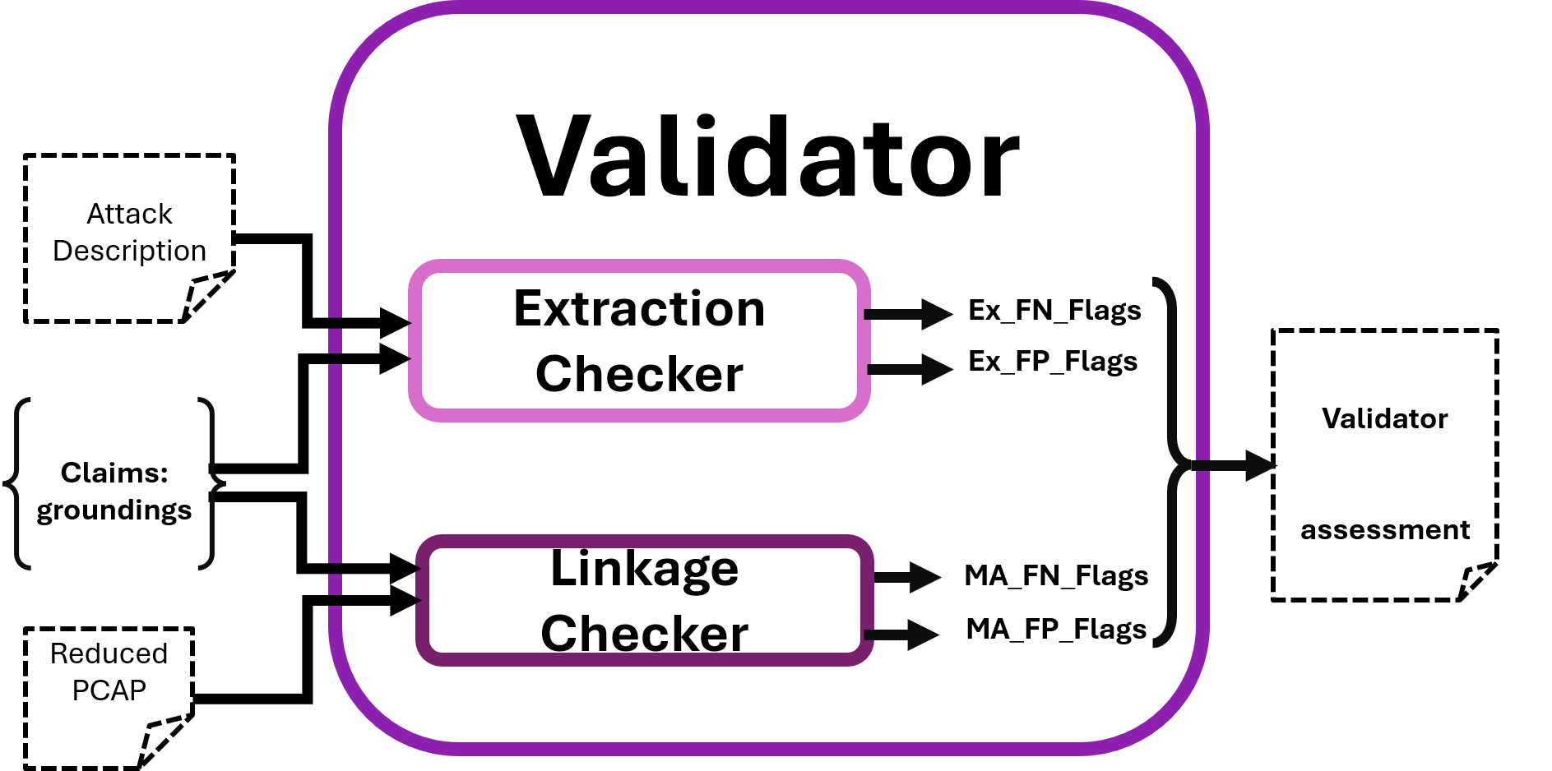

Reports and Visualization

Network Traffic Diagram

Reports and Visualization

Reports and Visualization

Rendering engine

Grid based diagrams

The cassowary algorithm –
- Implementation of Simplex
- Solve a system of constraints:
  - Create a compact diagram
  - No object is allowed to go on top of another
  - Allow for dynamic placement of objects

Improvement

Evaluation

Purpose
- The Evaluator measures how well the pipeline performs against a benchmark - not a single pass/fail judgment, but a per-stage assessment against ground truth, run both as a one-time measurement and as a repeatable regression tool for comparing pipeline versions over time (e.g., after a prompt change or model swap).

- The Evaluator is needed in addition to the Validator. It answers a fundamentally different question than the Validator. The Validator asks "do I suspect an error here?" in production, with no access to ground truth. The Evaluator asks "was that suspicion - and the underlying Grounder output - actually correct?", offline, with access to human-labeled ground truth. Without the Evaluator, there is no way to know whether the Validator itself is trustworthy, since the Validator is just another LLM judgment with no external check on its own accuracy.

Functionality
There are two distinct testing categories:
- Compliance Testing - Answers the questions: Did the process follow its own rules? Was the result correct?
- Accuracy Testing- based on human labeled data, comparison against labeled samples.

The Dataset

The dataset will include PCAPs describing attacks, protocols and regular traffic, and manual claims lists describing the traffic. Each claim in the list will map to a set of packets in the PCAP file.

Format
- Base PCAPs: of attacks, protocols and general network traffic, sourced from existing labeled datasets (e.g., ATT&CK-labeled traffic sets).
- Descriptions and claim-level ground truth: authored and annotated manually, since no existing dataset provides claim-to-packet granularity.
- Annotation process: single annotator with a double-pass reconciliation process (label, wait, re-label independently, reconcile disagreements) - full multi-annotator inter-rater agreement validation is deferred to future work, appropriate for POC scope.

Dataset Composition

Target ~10 PCAPs for POC, diversity-prioritized over volume:
- 2-3 PCAPs: small, clean, single attack-type - basic pipeline flow proof
- 2-3 PCAPs: large enough to force real compression (thousands of packets, includes scan/flood pattern) - proves Preprocessing's core value
- 1-2 PCAPs: deliberately exceeds token budget - proves R4 fail-loud behavior
- 1-2 PCAPs: protocol-conformance description (not attack) - proves domain generality
- PCAP: ordinary/benign traffic description - proves the "no attack" case works

Additional PCAPs may be added if evaluation reveals coverage gaps in the fixed set (e.g., a code path or grounding status no PCAP in the initial set exercises). Additions are logged with the specific gap they address, not made to adjust aggregate results after the fact.

Structure
The Evaluator forms a scoring report using the following sub modules:

Preprocessor_Eval

Compliance Testing (no ground truth required). Runs automated assertions against Preprocessing's output to confirm R1–R5 hold, for every run.

Requirement | Automated Check
R1 (Referential Integrity) | Iterate through all packets and check that every aggregated packet and packet metadata resolve back to the original packet
R2 (Temporal Order) | Output timestamps are monotonically non-decreasing, matching original capture orde
R3 (Aggregate Traceability) | Iterate through all packets and check that every aggregated packet and packet metadata resolve back to the original packet
R4 (Budget Compliance) | On budget-respecting inputs: estimated_tokens_out <= Token_Budget.  On inputs deliberately exceeding budget: Budget_status == "exceeded” is correctly set, with a valid stopping-point reference - not silent truncation
R5 (Protocol Agnosticism) | Running Preprocessing on two PCAPs with structurally identical traffic patterns but different attack-type labels produces structurally identical compression behavior (can be checked manually)

Output: binary PASS/FAIL per requirement, per test PCAP.

Grounder_Eval
Accuracy Testing (requires ground truth). Compares the Grounder's claims[], their linked packets and their grounding.status against manually labeled ground truth (claim text + correct linkage, per the annotation process established earlier).

Metrics produced:
- Extraction precision/recall - of claims the Grounder extracted, how many are genuine (precision)? Of claims that genuinely exist in the description, how many did it catch (recall)?
- Grounding precision/recall per status - of claims labeled `grounded` by the Grounder, how many are correctly grounded per ground truth? Of claims that should be `unsupported`, how many were correctly identified as such?
- Breakdown by claim type — accuracy split by claims with clean structured `expected_indicators` vs. claims relying on the free-text `indicator_description` fallback, to reveal whether errors concentrate in one path.

Validator_Eval

Meta-Accuracy Testing (requires ground truth). Checks whether the Validator's own flags (Ex_FP/Ex_FN/MA_FP/MA_FN with suspicion scores) match ground truth.

Metrics produced:
- Validator precision - of claims the Validator flagged as suspicious, how many were genuinely wrong (per ground truth)?
- Validator recall - of claims that were genuinely wrong, how many did the Validator catch (vs. silently passing them through unflagged)?

Output Schema
1. json
2. {
3. "preprocessing_eval": {
4. "R1_traceability": "PASS",
5. "R2_description_blindness": "PASS (structural)",
6. "R3_referential_integrity": "PASS",
7. "R4_temporal_order": "PASS",
8. "R5_budget_compliance": "PASS (exceeded correctly flagged on large_pcap_03)",
9. "R6_protocol_agnosticism": "PASS"
10. },
11. "grounder_eval": {
12. "extraction_precision": 0.0,
13. "extraction_recall": 0.0,
14. "grounding_precision": 0.0,
15. "grounding_recall": 0.0,
16. "breakdown_by_indicator_type": {
17. "structured": { "precision": 0.0, "recall": 0.0 },
18. "free_text_fallback": { "precision": 0.0, "recall": 0.0 }
19. }
20. },
21. "validator_eval": {
22. "validator_precision": 0.0,
23. "validator_recall": 0.0
24. },
25. "calibration_eval": {
26. "reliability_buckets": [
27. { "score_range": "0.8-0.9", "observed_accuracy": 0.0, "n": 0 }
28. ]
29. },
30. "meta": {
31. "dataset_size": 10,
32. "total_claims_evaluated": 0,
33. "eval_run_id": "...",
34. "pipeline_version": "..."
35. }
36. }
37.
38.

Visual Evaluation

4.2 Automatic Test

4.2.1 Structure:
- DiagramEval (2025):
  - Node Alignment
  - Path Alignment
- Graph Edit Distance (GED) between the LLM diagram's graph structure and the manual/ground-truth graph, as a structural-similarity complement to DiagramEval.

4.2.2 Visualization and Style:
- Visual Density:
$$graph density =\frac{edges}{\left[nodes × \left(nodes - 1\right)\right]}$$
Flags diagrams that are too cluttered (hard to read) or too sparse (missing relationships).

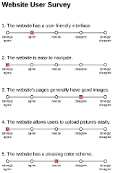
4.3 Qualitative Manual Test
- Human expert Likert-scale ratings (1–5) on
  - interpretability
  - correctness
  - operational usefulness
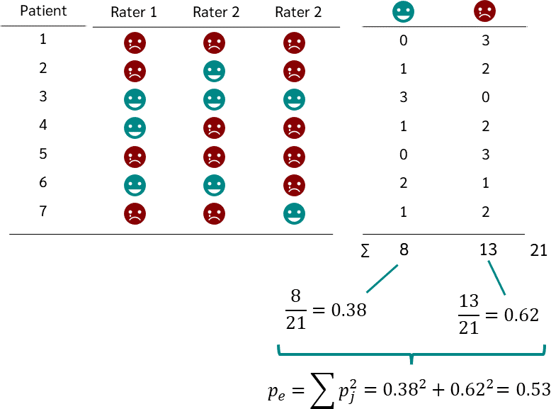
  - visuality

- Reliability of agreement: Inter-rater agreement (Cohen's/Fleiss' kappa) across multiple human evaluators to check consistency of the manual scoring.

4.4 Additional Testbench Ideas

4.4.1 Designing a Dataset
- Labeled PCAPs with ground-truth attack input descriptions
- Include benign and attack traffic to avoid FPs.
- Sources: DARPA intrusion-detection datasets, CICIDS2017, or CTF traffic captures

4.4.2 System Prompt
- Vary prompt structure (zero-shot, few-shot examples, chain-of-thought...) to see which prompting strategy most improves Coverage and Sequence Fidelity.

4.4.3 Robustness – Different input description
- Noisy inputs: use benign traffic or messy attack structures to test Noise Filtering Rate.
- Vary the input description details granularity to isolate what drives diagram quality.
- Scalability: measure how diagram quality degrades as PCAP duration/size grows, especially for long multi-stage attacks.
- Consistency: re-run the same PCAP + description multiple times (varying temperature/seed) to measure output variance — a benchmark should penalize high run-to-run instability.

4.4.4 Efficiency and Cost
Costs depend on:
  - LLM inference latency
  - Token amount and cost per diagram
  - Model used
- Measure cost and latency over:
  - Different models
  - Instructions of different detailing levels
  - Differing Input PCAPs/descriptions

Evaluation Implementation Summary

Challenges

- Minimizing LLM calls –

Structural Correctness – Coverage

Ensures the LLM diagram includes all components: Significant Actors, Attack Phases, Steps.
- No False Negatives (Recall): Do all components in the ground-truth appear in the evaluated content?

$$Recall =\frac{matched components}{ground-truth components}$$

- No False Positives (Precision): Are there components in the evaluated content that don't exist in the ground-truth?
$$Precision = \frac{matched components}{ total predicted components}$$
- Final Coverage Score: Component-level F1 harmonic mean of the two above.

3.1.2 Sequence Fidelity
- Does the diagram preserve the correct causal ordering of components (attack phases and steps) as appear in the Ground Truth?
Measurement Methods:
  - Longest Common Subsequence (LCS) between the ground-truth step order and the evaluated content's order.
    - LCS Cares more if a step was dropped (False Negative) than addition of steps - noise (False Positive)
    - How much of the “main story” is correct?
$$\text{True}=\left[\text{Scan}, \text{Exploit} ,\text{Brute_Force} ,\text{C2} , \text{Exfil}\right]$$
$$\text{Pred}=\left[\text{Scan}, \text{ARP_Noise}, \text{Exploit}, \text{C2}, \text{DNS_Query}, \text{Exfil}\right]$$
$$LCS:Scan→Exploit→C2→Exfil$$
$$4 out of 5→0.8 (normalized)$$
  - Edit distance (Levenshtein) between the two step sequences – used to indicate how much edits need to be done to correct what’s wrong
    - Punishes for redundant steps.
    - Shows how far the diagram is from a manual diagram (“needs 3 fixes”)

  - Kendall's Tau / Spearman rank correlation between step orderings, for a normalized ordering score. Looking for “big mistakes” (for example, too many inversions)

0
+1
-1
Completely out of order
Same order in GT and EC
Opposite order

Follow up questions:
- The Semantic Synonymy Problem – PCAPs and descriptions are written in “different languages”. It is better to use LLM first to extract steps from both files in the same format and tokens.

Advarsarial agent – check semantic precision.

